Materials Needed:
- 3.5" Martelli square template
- 14.5" Martelli t-shirt template
- 2 coordinating fat quarters
- 1 fat quarter of fusible fleece

Cutting Instructions from Fabric
Tissue Box:
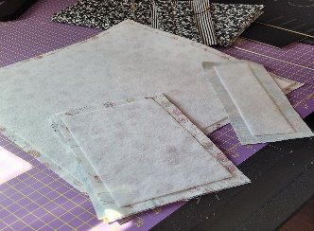
- Cut (2) 14.5" squares using the fat quarter template
Mug Rug:
- Cut (2) 5" x 9" pieces of fabric
Bookmark:
- Cut (2) 3"x10" pieces of fabric
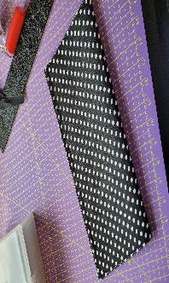
Cutting Instructions from Fusable Fleece
- Cut (1) 13.5" square for tissue box
- Cut (1) 4"x8" pieces for mug rugs
- Cut (1) 2"x9" piece for bookmark
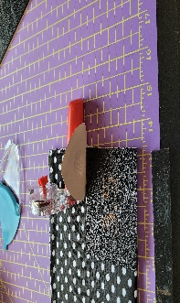
Tissue Box Assembly:
- Iron the 13.5" piece of fusible fleece to the wrong side of one14.5” square
- Place right sides of 14.5” fabrics together
- Take both 14.5" squares of fabric and sew 1/4" all the way around leaving an opening to flip right sides out
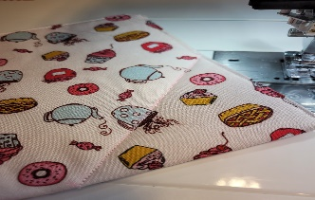
- Clip corners of bulk before turning right sides out. When turning right sides out make sure corners are nice and pointy
- Iron down opening so seams lay flat
- Top stitch 1/8" all around to secure opening closed. If you wish to embellish you may do so at this point
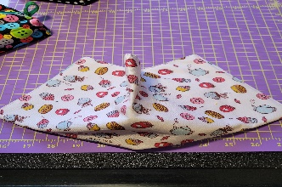
- Fold in half. (what you see now is the outside of your tissue box so pick which fabric you want outside at this time
- At the fold, place 3.5" template. Measure up the side 3.5" and mark. Measure along fold 3.5" and mark
- Draw a line joining marks
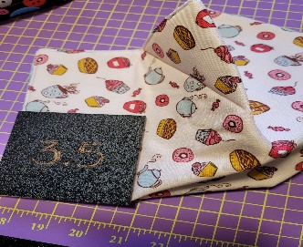
- Sew along this line and do the same procedure on other side
- Fold in half the other way and using 3.5" template make your marks the same way on both sides and sew on line and you will now have a box
- Take two of the flaps and stitch together at points to secure
- Do the same with remaining two flaps
- Tissue box is now complete and it's also reversible
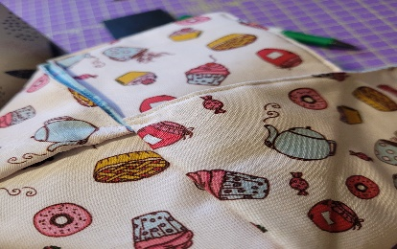
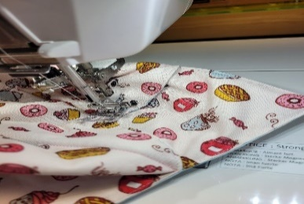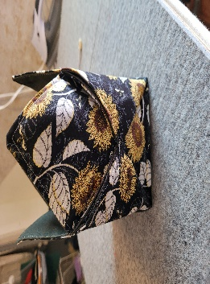

Mug Rug Assembly:
- Take (2) 5 " x 9" mug rug fabrics and place right sides together
- Iron 4"x 8" fusible fleece to wrong side of one fabric piece
- Place both 5 " x 9" mug rug fabrics right sides together
- Sew 1/4" all the way around leaving an opening to flip right sides out (Remember to backstitch at beginning and ending of opening)
- Clip corners of bulk before turning right sides out. When turning right sides out make sure corners are nice and pointy
- Iron down opening so seams lay flat and top stitch 1/8" all around to secure the opening closed
- Do this process for your second mug rug
- You can now quilt or use decorative stitches on your mug rugs, and call these done

Bookmark Assembly:
- Take 3" x 10" bookmark fabrics and put right sides together. Iron the (1) 2"x 8" pieces of fusible fleece to wrong side of one of the fabrics
- Place both 3"x 10" bookmark fabrics right sides together and sew 1/4" all the way around leaving an opening to flip right sides out (Remember to backstitch at beginning and ending of opening)
- Clip corners of bulk before turning right sides out. When turning right sides out make sure corners are nice and pointy
- Iron down opening so seams lay flat. Top stitch 1/8" all around to secure opening closed
- You can now quilt or use decorative stitches on your bookmark, and call this done.

ENJOY!

